SIMATS ENGINEERING
(SAVEETHA SCHOOL OF ENGINEERING)
Department of Computer Science and Engineering
CO2 ASSESSMENT TOOL 1 – SCENARIO-BASED REQUIREMENT ANALYSIS

Course Code: CSA1013
Course Title: Software Engineering
CO Assessed: CO2
Assessment: Assessment Tool 1 – Scenario-Based Requirement Analysis
Weightage: 20%
Total Marks: 25
Duration: 60 minutes

Student Name: P SOMA SHANKAR REDDY
Reg. No.: 192465066
Date: 05/08/2026
Code of Conduct
I certify that this submission is my original work and that I have adhered to the guidelines specified for this assessment. I understand that any violation of academic integrity rules will result in disciplinary action.

17. AI-Based Road Surface Damage Detection and Maintenance Planning System
Industry Context
Road infrastructure requires regular maintenance to ensure public safety and efficient transportation. Manual road inspections are labor-intensive, expensive, and often fail to identify defects promptly. Artificial Intelligence, Computer Vision, Drone Imaging, and Geographic Information Systems (GIS) enable automated road condition assessment and predictive maintenance planning.
Problem Statement
Roads frequently develop cracks, potholes, and surface deterioration due to traffic load and environmental conditions. Conventional inspection methods rely on manual surveys, which are time-consuming and prone to human error. There is a need for an AI-based system capable of automatically detecting road damage from images captured by cameras or drones. The platform should classify road defects, estimate severity, prioritize maintenance activities, and generate GIS-based maintenance schedules. Such a solution will improve road safety while reducing maintenance costs.
Objectives
1. Detect road surface defects using AI.
2. Classify potholes and pavement cracks.
3. Estimate damage severity.
4. Generate GIS-based maintenance maps.
5. Prioritize repair activities.
6. Monitor road condition over time.
7. Produce infrastructure health reports.
8. Reduce inspection costs.
Expected Outcomes
1. Accurate road damage detection.
2. Faster maintenance planning.
3. Improved road safety.
4. Reduced infrastructure maintenance costs.
5. Efficient resource allocation.
6. Enhanced transportation quality.
7. Continuous infrastructure monitoring.
8. Increased public satisfaction.

Software Requirement Specification (SRS)
AI-Based Road Surface Damage Detection and
Maintenance Planning System
Prepared in accordance with the CSA10 – Software Engineering (CO2: Requirements Analysis, Architecture Design, and Feature Prioritization) scenario-based assessment guidelines.

1. Introduction
Road infrastructure is a critical public asset that requires continuous monitoring and timely maintenance to ensure the safety of commuters and the efficiency of transportation networks. Surface defects such as cracks and potholes develop steadily due to repeated traffic loading, rainfall, and temperature variation, and if left unaddressed they accelerate pavement deterioration and increase the risk of accidents.
Traditional road inspection is carried out manually by field engineers who physically survey road stretches. This method is slow, labour-intensive, expensive to scale across large road networks, and highly dependent on the inspector's judgement, which introduces inconsistency and the possibility of missed defects. Recent advances in Artificial Intelligence, Computer Vision, drone-based imaging, and Geographic Information Systems (GIS) make it possible to automate this process end-to-end.
This document presents the Software Requirement Specification (SRS) for the proposed AI-Based Road Surface Damage Detection and Maintenance Planning System. It captures the functional and non-functional requirements, system actors and use cases, data and interface requirements, assumptions, constraints, and a validation of the requirement set, prepared as part of the CSA10 Scenario-Based Requirement Analysis assessment.

2. Problem Description
Roads frequently develop cracks, potholes, and general surface deterioration as a consequence of traffic load and environmental exposure. Conventional inspection methods rely on manual surveys conducted by road engineering staff walking or driving along road stretches with a checklist, which is time-consuming, costly to repeat at regular intervals, and prone to human error and subjective severity judgement.
There is a clear need for a system that can automatically detect road damage from images captured by vehicle-mounted cameras or drones, classify the type of defect, estimate its severity, and translate this into a prioritised, GIS-referenced maintenance schedule. Such a system would allow municipal and highway authorities to move from reactive, complaint-driven repairs to a proactive, data-driven maintenance strategy -- improving road safety while reducing the overall cost of inspection and upkeep.

2.1 Business Domain, Stakeholders, and System Objectives
Business Domain: Public Infrastructure and Transportation Asset Management, at the intersection of Computer Vision / AI and civil engineering maintenance operations.
Key Stakeholders:
- Municipal / Highway Authority — owns road assets and funds maintenance
- Field Inspectors and Drone Operators — capture road surface imagery
- Maintenance Engineers — review defects and schedule repairs
- GIS Analysts — maintain spatial maintenance maps
- System Administrators — manage users, access, and system configuration
- Traffic Authority — consumes reports affecting traffic advisories
- Citizens / Commuters — indirect beneficiaries of safer, better-maintained roads
System Objectives:
- Detect road surface defects automatically using AI-based computer vision
- Classify defects into categories such as potholes and pavement cracks
- Estimate the severity of each detected defect
- Generate GIS-based maintenance maps for affected road segments
- Prioritise repair activities based on severity and traffic impact
- Monitor road condition over time to track deterioration and repair effectiveness
- Produce infrastructure health reports for decision-makers
- Reduce the cost and turnaround time of manual road inspection

3. Scope of the System

3.1 In Scope
- Ingestion of road images/video from vehicle-mounted cameras and drones
- AI-based detection and classification of surface defects (cracks, potholes)
- Severity estimation and confidence scoring for each detected defect
- Geo-tagging of defects and generation of GIS-based maintenance maps
- Rule-based prioritisation of repair activities
- Historical monitoring of road condition and trend reporting
- Dashboard and report generation for engineers and administrators

3.2 Out of Scope
- Physical execution of road repair work (handled by maintenance contractors)
- Manufacturing or maintenance of drone / camera hardware
- Direct integration with traffic signal control systems
- Autonomous drone flight path planning (assumed handled by drone operator / existing flight software)

4. Functional Requirements
The functional requirements describe the specific behaviours and capabilities the system must provide.
ID | Requirement | Description
FR-1 | Image/Video Capture Integration | Accept image and video input from vehicle-mounted cameras and drones.
FR-2 | Image Upload & Preprocessing | Allow field staff to upload captured media; preprocess (resize, denoise, normalise) before analysis.
FR-3 | AI-Based Defect Detection | Detect road surface defects (cracks, potholes) in images using a trained computer-vision model.
FR-4 | Defect Classification | Classify each detected defect by type and sub-category (e.g., longitudinal crack, alligator crack, pothole).
FR-5 | Severity Estimation | Estimate severity of each defect (e.g., Low / Medium / High) based on size, depth, and spread.
FR-6 | Geo-Tagging of Defects | Associate each defect with GPS coordinates and road segment ID captured at the time of imaging.
FR-7 | GIS Maintenance Map Generation | Plot detected defects on a GIS map layer to visualise their location and severity.
FR-8 | Maintenance Prioritisation | Rank road segments/defects for repair based on severity, traffic volume, and repair history.
FR-9 | Road Condition Monitoring | Track condition of a given road segment across multiple inspection cycles over time.
FR-10 | Infrastructure Health Report Generation | Generate periodic summary reports of overall road network health for stakeholders.
FR-11 | User & Role Management | Support role-based access for inspectors, engineers, GIS analysts, and administrators.
FR-12 | Alerts & Notifications | Notify maintenance engineers when a high-severity defect is detected.

5. Non-Functional Requirements
Non-functional requirements define the quality attributes and operating constraints the system must satisfy.
Category | Requirement
Performance | Defect detection on a submitted image shall complete within 5 seconds under normal load.
Security | All uploaded imagery and location data shall be encrypted in transit and at rest; access shall be role-based.
Reliability | The system shall maintain a minimum detection model accuracy of 90% on the validation dataset.
Usability | Dashboards shall be usable by non-technical maintenance staff with minimal training.
Scalability | The system shall support onboarding of additional road zones and increasing image volume without redesign.
Maintainability | The AI model shall be retrainable and deployable independently of the rest of the application.
Availability | Core services (upload, dashboard, reporting) shall be available at least 99% of the time.
Interoperability | GIS outputs shall be exportable in standard formats compatible with common GIS tools.
Accuracy | False-positive rate for defect detection shall be kept below an agreed acceptable threshold.

6. Actors and Use Cases

6.1 Primary Actors
- Drone / Field Inspector — captures and uploads road surface imagery
- Maintenance Engineer — reviews detected defects and plans repairs
- GIS Analyst — manages and reviews the GIS maintenance map layer
- System Administrator — manages users, roles, and system configuration

6.2 Secondary Actors
- Traffic Authority — consumes health reports and maintenance maps for advisories

6.3 Major Use Cases
- Capture road images via camera or drone
- Upload and preprocess images
- Detect road surface defects
- Classify crack / pothole type
- Estimate damage severity
- Generate GIS maintenance map
- Prioritise repair activities
- Monitor road condition over time
- Generate infrastructure health report
- Manage users and system access
- Share reports with the traffic authority
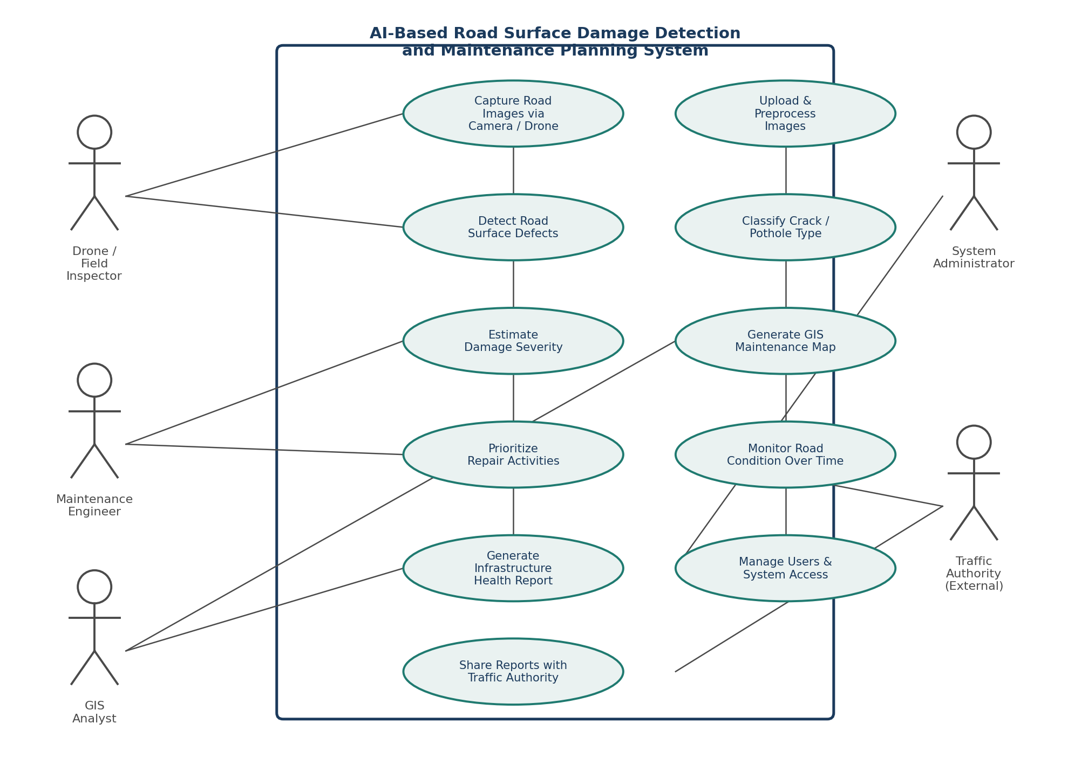
Figure 1: Use Case Diagram — AI-Based Road Surface Damage Detection and Maintenance Planning System

7. Data Requirements

7.1 Input Data
- Captured road images / video frames
- GPS coordinates and timestamp of capture
- Road segment / asset identifier

7.2 Processed / Derived Data
- Defect type and sub-category label
- Model confidence score
- Severity level (Low / Medium / High)
- Geo-tag linking defect to map coordinates

7.3 Stored Data
- Historical inspection records per road segment
- Maintenance activity logs and repair history
- User accounts, roles, and access logs

7.4 Output Data
- Prioritised maintenance schedules
- Infrastructure health reports
- GIS maintenance maps

8. External Interface Requirements

8.1 User Interfaces
- Web dashboard for maintenance engineers, GIS analysts, and administrators
- Mobile application for field inspectors to capture and upload imagery

8.2 Hardware Interfaces
- Vehicle-mounted and drone-mounted cameras
- GPS modules for location tagging

8.3 Software Interfaces
- GIS platform / API (e.g., QGIS or ArcGIS-compatible export) for map generation
- Cloud object storage for raw and processed imagery
- Relational / spatial database for defect and maintenance records

8.4 Communication Interfaces
- REST APIs between mobile capture app, backend AI service, and dashboard
- Secure cloud synchronisation for offline-captured field data

9. System Features
- AI Defect Detection Engine — computer-vision model that locates and classifies surface defects
- Severity Scoring Module — quantifies defect severity from visual features
- GIS Mapping & Visualisation — plots defects and maintenance zones on a spatial map
- Maintenance Prioritisation & Scheduling — ranks repairs by severity, cost, and impact
- Reporting & Analytics Dashboard — summarises road network health over time

9.1 System Architecture Overview
The system is organised into four layers: a Data Acquisition Layer that collects field imagery and location data, a Data Processing & AI Layer that performs detection, classification, and severity estimation, a GIS Integration Layer that geo-tags defects and produces maintenance maps, and an Application & Reporting Layer that exposes dashboards and reports to end users.
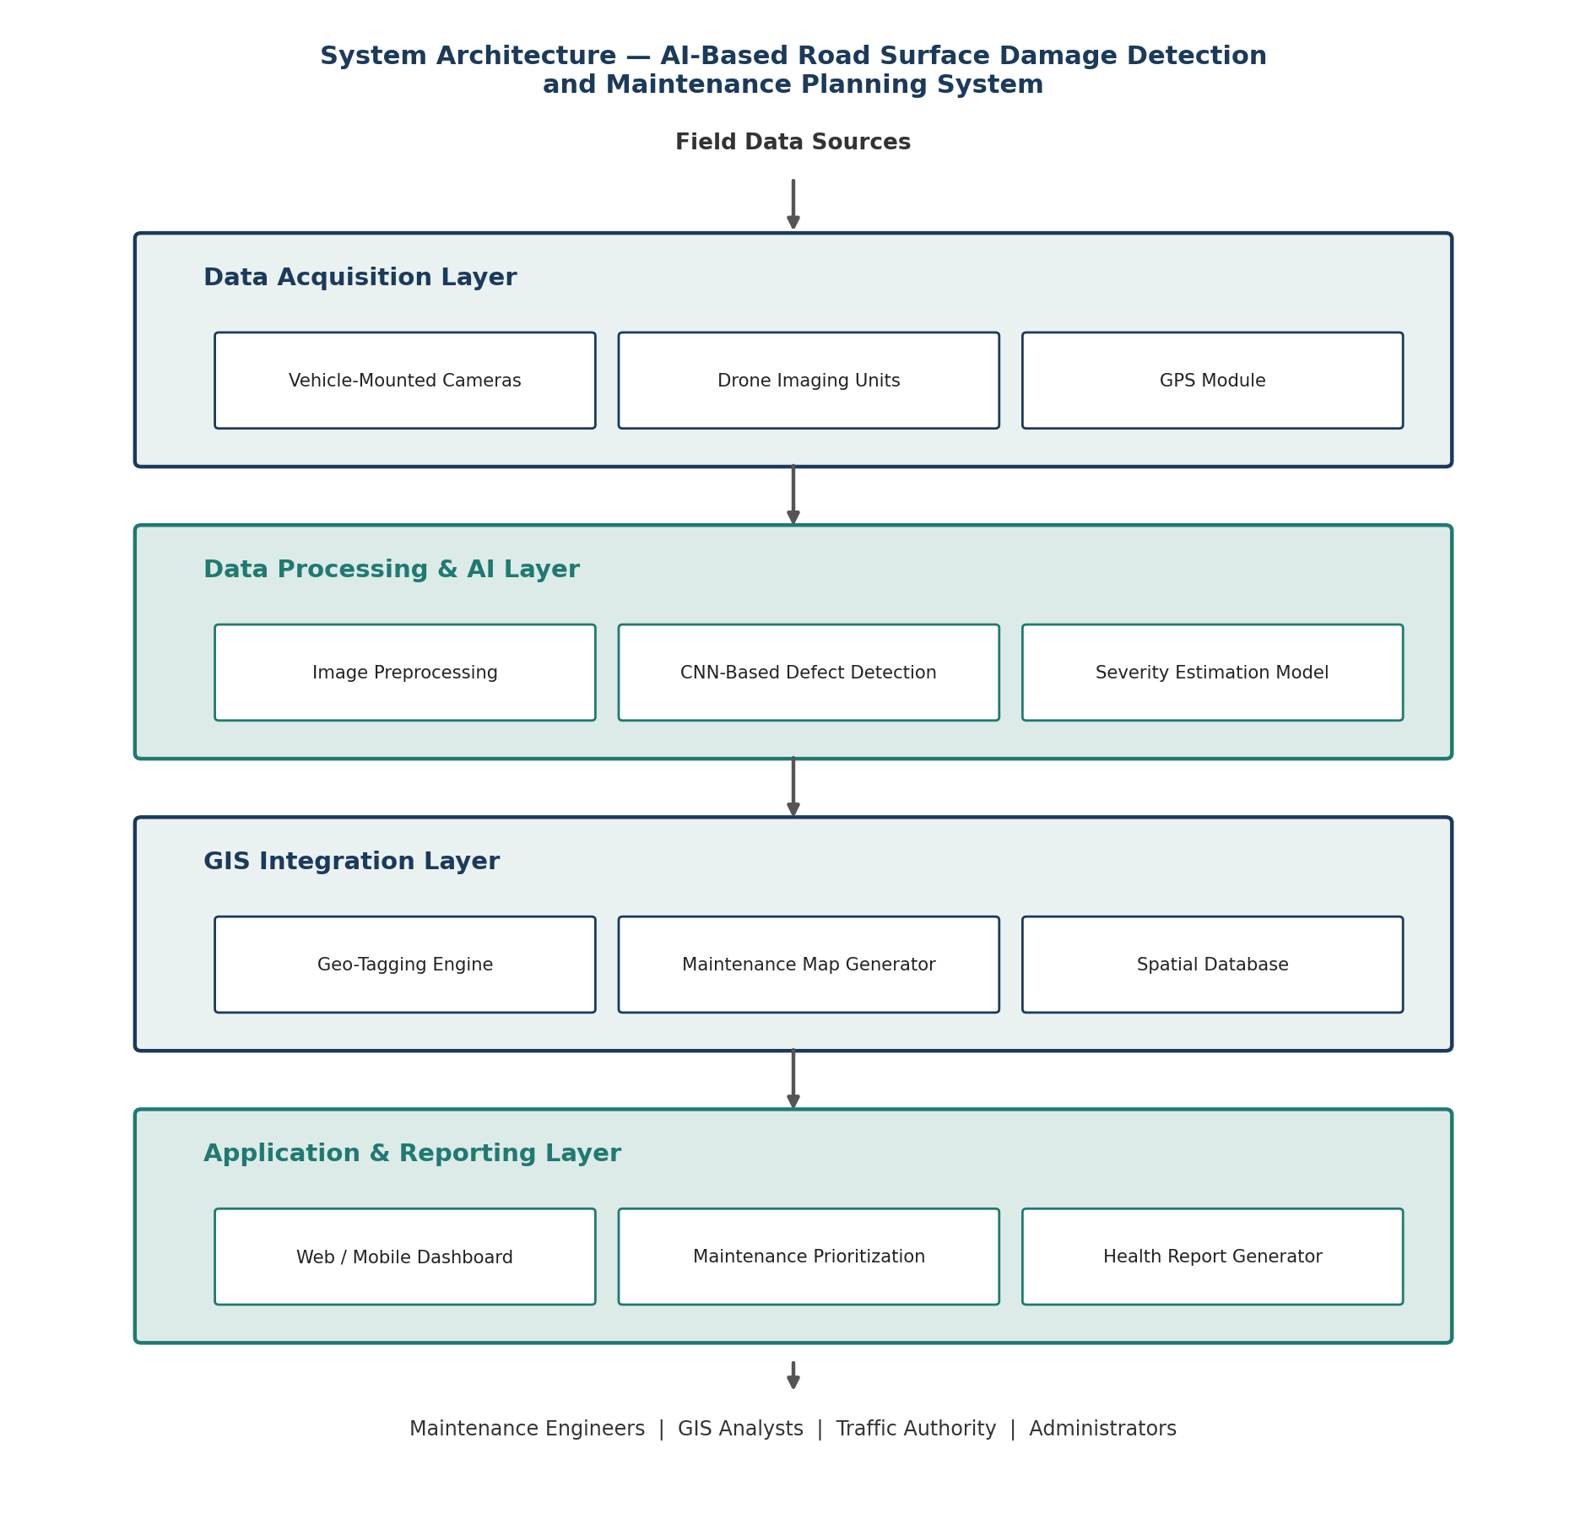
Figure 2: Layered System Architecture

10. Assumptions and Constraints

10.1 Assumptions
- Captured images are of sufficient resolution and lighting quality for reliable defect detection.
- Vehicle-mounted cameras or drones with GPS capability are available for the pilot road network.
- Field locations have network connectivity, or the app can queue uploads for later synchronisation.
- Reference road segment data (road IDs, boundaries) already exists with the municipal authority.

10.2 Constraints
Type | Description
Technical | Detection accuracy is dependent on the quality and diversity of the training dataset; model training requires GPU resources.
Operational | Field staff require basic training on drone operation and the mobile capture application.
Economic | Budget must cover drone/camera hardware, cloud storage, and compute for model training and inference.
Legal | Imagery captured in public spaces must comply with data privacy norms and local drone-flight regulations.
Time | Development and deployment must fit within the project's academic / delivery timeline.

11. Requirement Validation — Completeness and Consistency

11.1 Traceability to Stated Objectives
Objective (from Problem Statement) | Mapped Requirement(s) | Status
Detect road defects using AI | FR-3 | Addressed
Classify potholes and pavement cracks | FR-4 | Addressed
Estimate damage severity | FR-5 | Addressed
Generate GIS-based maintenance maps | FR-6, FR-7 | Addressed
Prioritise repair activities | FR-8 | Addressed
Monitor road condition over time | FR-9 | Addressed
Produce infrastructure health reports | FR-10 | Addressed
Reduce inspection costs | FR-1, FR-2 (automation) | Addressed indirectly

11.2 Completeness and Consistency Check
- All eight objectives listed in the problem statement are traceable to at least one functional requirement.
- No conflicting requirements were identified between the detection, GIS, and reporting modules.
- Minor ambiguity noted: exact severity thresholds (Low/Medium/High) are not numerically defined and should be finalised with domain experts.
- Missing requirement identified: no explicit requirement for handling false-positive feedback from engineers — added as a suggested improvement below.

11.3 Suggested Improvements
- Define quantitative severity thresholds (e.g., pothole depth/diameter ranges) during the design phase.
- Add a feedback loop allowing engineers to flag false positives to improve the AI model over time.
- Define a service-level target (e.g., maintenance map refresh within 24 hours of new inspection data).

12. Conclusion
This Software Requirement Specification captures the functional scope, quality attributes, actors, data flows, and system architecture required for an AI-based road surface damage detection and maintenance planning system. The requirement set has been validated against the original problem statement's objectives and refined with suggested improvements, providing a solid foundation for subsequent design and development phases of the project.

